Circle Language Spec: Relations

Relations Between Objects

Concept
Relations between classes set the rules for how objects can be connected to eachother.

Relations between objects are the actual connections.

A relation between objects is always a relation between two individual objects. If one object refers to another, the other refers back to the first one.

From a 1 → 1 perspective this seems logical, but from an n → n perspective this may not seem logical.

A relation between two classes with each a multiplicity of n, creates a related list in both of the classes. Every object of those classes will contain a related list of related items.
Any object that as a relation to another object, gives the other object one relation back to the first object. So for each reference to an object, the other object contains a reference back. One reference inside an object is tied to one reference inside another object.

One object can relate to multiple objects, so an object can have a one-to-many relation to other objects, but one related item in one object always creates one related item inside the other object.

Diagram Notation
The concept of relations between objects is explained in the article Relations Between Objects. The current article only explains its expression in a diagram.

The main rule about relations to object is: for each reference to an object, the other object contains a reference back.

When you draw out the separate counterparts of a relation between two objects it looks like this:

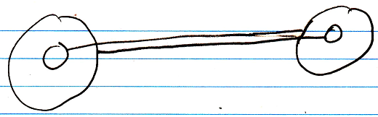

But to express the close relation between the two references, the two lines are merged, and disambiguated from normal object lines with a relation symbol:

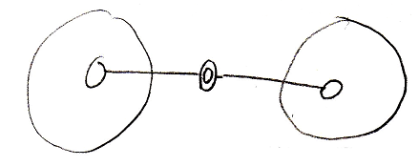

The relation symbol is a double circle. The reason behind this notation, was already explained in the article Relations in a Diagram. The notation is accomplished by first taking the original picture with one class refering to another and the other refering back to the first class:

Then, an imaginary reference to each class is added to the diagram

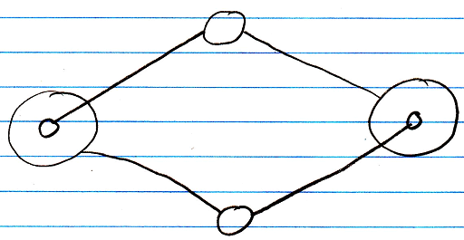

Next, the class lines are merged, but also the class symbols are merged:

The notation would still be ambiguous, if it weren’t for the double line of the merged object symbols. So a double circle symbolizes a relation between objects.

For relations between classes the relation symbol is a double dashed circle. For relations between objects, the relation symbol is a double circle drawn with solid lines.

In 1 → n and n → n relations the rule, that each reference contains one reference back, also applies:

1 → n:

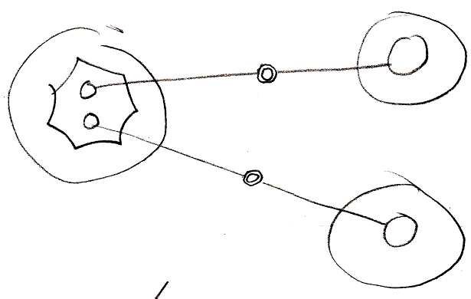

n → n:

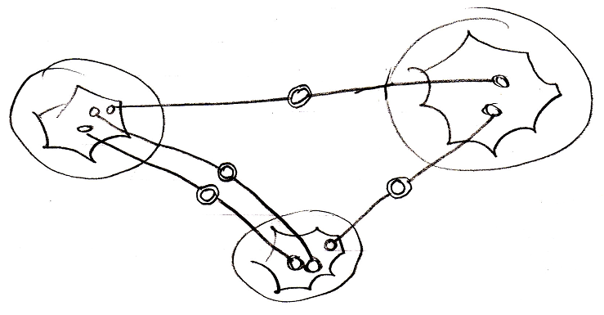

It doesn’t matter whether an object reference is part of a list or not: every time it is still two individual object references, that are tied together.

Object relating to itself
Sometimes an object relates to itself. In a diagram this looks as follows:

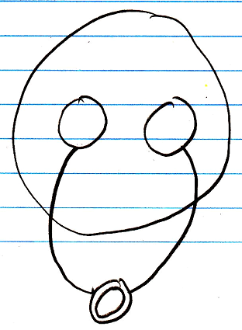

Counterpart out of sight
When the counterpart of the relation is out of sight, a line should point out of the diagram. A catch there is, that you can’t see if the relation counterpart is part of a multiplicity of n or not. Therefore, the multiplicity is expressed at the end of th line pointing out of the diagram as follows:

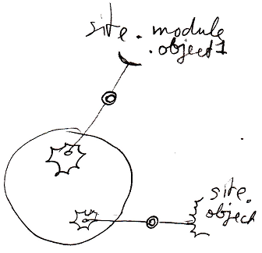

No reuse of merged imaginary references
If two imaginary references have merged, to become a relation symbol, then other references to the same objects won’t connect to an imaginary reference that has merged to become a relation symbol. Relations create their own imaginary references, that aren’t reused.

Here is a relation between two objects:

The two objects refer to eachother. This originally consisted of two distinct references:

Imaginary references were put on one level higher:

If other references to the same objects were also displayed in the diagram, then they would connect to the same imaginary references, put on a higher level:

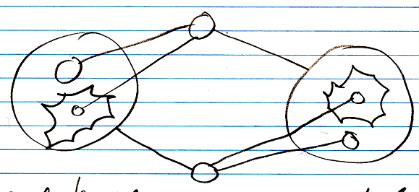

When you merge the imaginary references to display that two references are part of a single relation, you will not connect all
references to the merged imaginary reference:

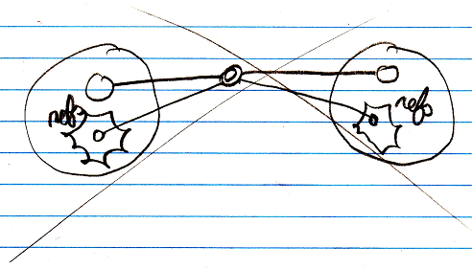

You will keep separate imaginary references for the other unary relations to the objects:

